29.Write a Python programming to display a bar chart of the popularity of programming Languages. Use different color for each bar.
Aim:
To write a Python program to display a bar chart showing the popularity of different programming languages, using a different color for each bar.
Program:
import matplotlib.pyplot as plt
languages = ['Python', 'Java', 'C++', 'JavaScript', 'C']
popularity = [90, 75, 70, 85, 60]
colors = ['red', 'blue', 'green', 'orange', 'purple']
plt.bar(languages, popularity, color=colors)
plt.xlabel('Programming Languages')
plt.ylabel('Popularity')
plt.title('Popularity of Programming Languages')
plt.show()
Output:
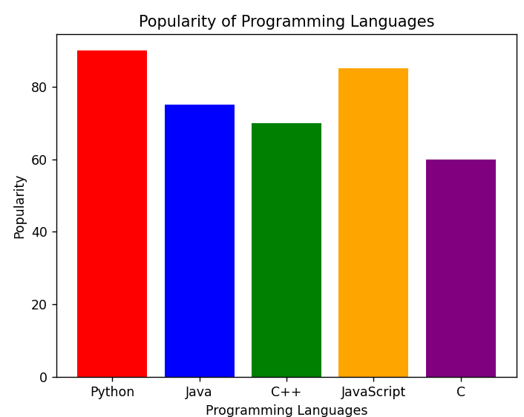
Result:
Thus, the Python program to display a bar chart of the popularity of programming languages with different colors for each bar was successfully executed.

30.Write a Python program to create bar plot of scores by group and gender. Use
multiple X values on the same chart for men and women.
Aim
To write a Python program to create a bar plot of scores by group and gender, displaying the scores of men and women using multiple X-values on the same chart.
Program:
import matplotlib.pyplot as plt
languages = ['Python', 'Java', 'C++', 'JavaScript', 'C']
popularity = [90, 75, 70, 85, 60]
colors = ['red', 'blue', 'green', 'orange', 'purple']
plt.bar(languages, popularity, color=colors)
plt.xlabel('Programming Languages')
plt.ylabel('Popularity')
plt.title('Popularity of Programming Languages')
plt.show()
Output:
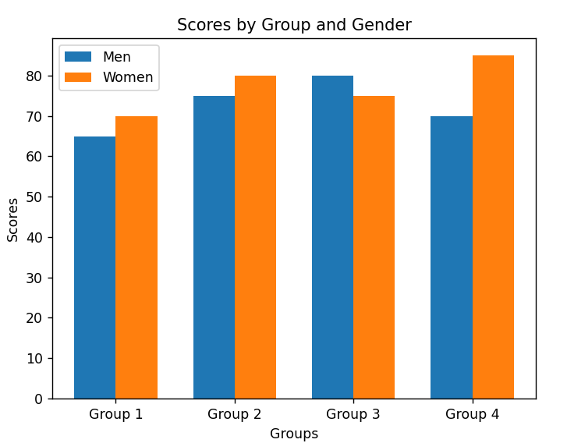
Result:
Thus, the Python program to create a bar plot of scores by group and gender using multiple X-values for men and women was successfully executed.

